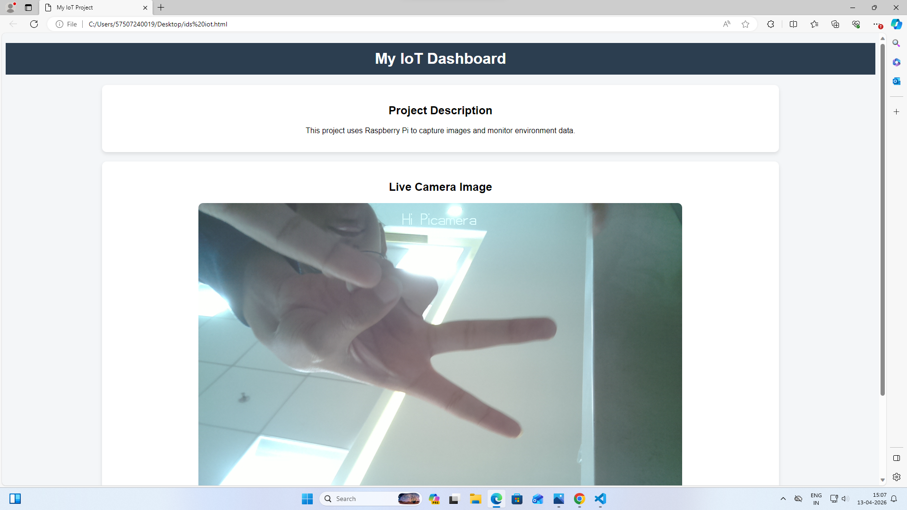
<!DOCTYPE html>
<html lang="en">
<head>
<meta charset="UTF-8">
<title>My IoT Project</title>
<style>
body {
font-family: Arial, sans-serif;
background: #f4f6f8;
text-align: center;
}
h1 {
background: #2c3e50;
color: white;
padding: 15px;
}
.container {
width: 80%;
margin: auto;
}
.card {
background: white;
padding: 20px;
margin: 20px;
border-radius: 10px;
box-shadow: 0 4px 8px rgba(0,0,0,0.1);
}
img {
max-width: 100%;
border-radius: 10px;
}
</style>
</head>
<body>
<h1>My IoT Dashboard</h1>
<div class="container">
<!-- Project Info -->
<div class="card">
<h2>Project Description</h2>
<p>This project uses Raspberry Pi to capture images and monitor environment data.</p>
</div>
<!-- Raspberry Pi Image -->
<div class="card">
<h2>Live Camera Image</h2>
<img src="C:\Users\57507240019\Downloads\image1.jpeg" alt="Raspberry Pi Capture">
</div>
</div>
</body>
</html>

